Business Data Analyzer
Desktop business analytics application for sales, inventory, profitability, and data quality analysis.

Overview
Business Data Analyzer helps you:
- Analyze sales and inventory data
- Validate data quality before reporting
- Detect join and mapping issues
- Calculate profitability and margins
- Export formatted Excel reports
- Explore trends and business insights
Built with:
- Python
- Streamlit
- Pandas

Features

Sales Analysis
- Revenue analysis
- Sales trends
- Product performance
- Customer performance
- Profitability analysis
- Margin analysis

Inventory Analysis
- Stock visibility
- Low stock detection
- Overstock identification
- Reorder monitoring
- Supplier analysis

Smart Data Preparation
- Automatic column mapping
- Alias-aware matching
- Manual mapping override
- Validation reporting
- Join diagnostics
- Preflight risk scoring

Reporting
- Excel export
- Validation diagnostics
- Cleaned datasets
- Analysis summaries

System Requirements
- Windows 10 or later
- Python 3.10+
- Internet connection required only for Python package installation on first launch

Installation

1. Install Python
Download Python:
urlPython Downloadshttps://www.python.org/downloads/
During installation:
✅ Tick:
Add Python to PATH

2. Extract the Application
Extract the downloaded ZIP file to any folder.
Example:
C:\BusinessDataAnalyzer

3. Launch the App
Double-click:
run_app.bat
On first launch:
- A virtual environment will be created
- Required packages will be installed
- Your browser will open automatically
This may take several minutes on first run.

Using the App

Option 1 — Load Demo Data
Use built-in demo datasets to explore features quickly.
Available demos:
- Sales Demo
- Inventory Demo
- Full Demo (Sales + Customer + Product Masters)

Option 2 — Upload Your Own Data
Supported formats:
- CSV
- XLSX
- XLS
Recommended datasets:
- Sales exports
- Inventory exports
- Customer master data
- Product master data

Profitability Analysis Requirements
Profitability analysis requires:
- Quantity
- Unit Price
- Either:
  - Unit Cost in the sales file
  - OR Product Master with Base Cost

Example Data Fields

Sales Dataset
Business Field | Example Column Names
Date | Order Date
Product | Product Name
Quantity | Qty Sold
Unit Price | Selling Price
Unit Cost | Unit Cost
Customer | Client Name

Inventory Dataset
Business Field | Example Column Names
Product | Product Name
SKU | SKU Code
Stock On Hand | Current Stock
Reorder Level | Minimum Stock
Supplier | Supplier Name

Troubleshooting

Browser does not open
Open manually:
http://localhost:8501

Python not found
Reinstall Python and ensure:
Add Python to PATH
was enabled during installation.

First launch is slow
The application installs required packages on first run.
Subsequent launches will be much faster.

Folder Structure
BusinessDataAnalyzer/
├── app.py
├── run_app.bat
├── requirements.txt
├── analytics/
├── config/
├── data_cleaning/
├── reporting/
├── utils/
├── demo_data/
└── screenshots/

Version

v1.0
Included:
- Sales analysis
- Inventory analysis
- Profitability analysis
- Smart column mapping
- Validation reporting
- Excel export
- Demo mode

Planned Features
- Saved mapping profiles
- Forecasting
- Customer segmentation
- Product segmentation
- Run history
- Expanded test coverage

Support
If you encounter issues during review/testing:
- Include screenshots where possible
- Include sample files if relevant
- Include error messages shown in the console or browser

License
Internal review build.

Screenshots

Dashboard Overview
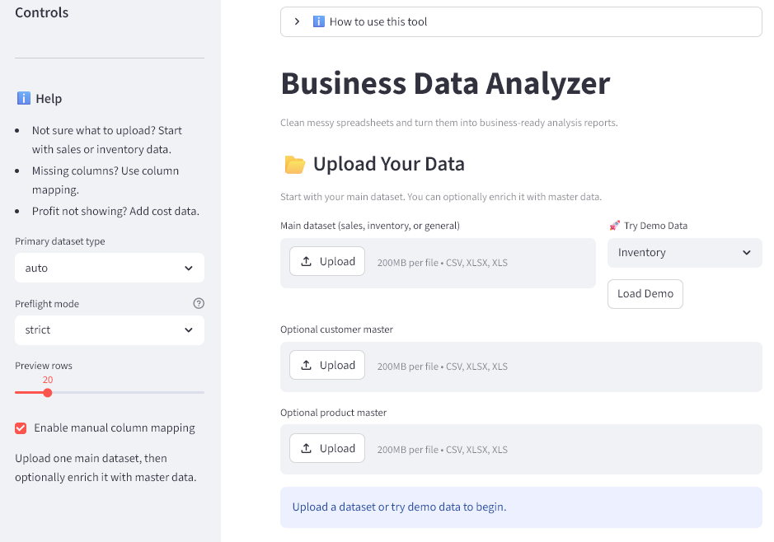

Column Mapping
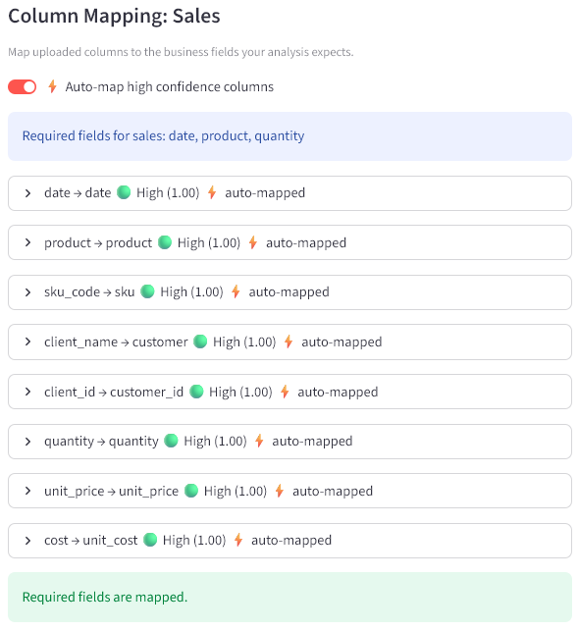

Profitability Analysis
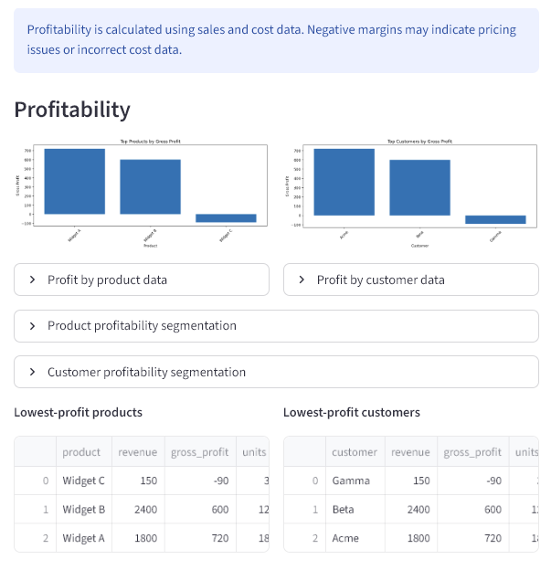

Inventory Analysis
